DATABASE WITH AUTO_INCREMENT SEQUENCES

AIM:
To create Auto Increment sequence on the given relation.
DESCRIPTION:
SEQUENCE:
In MySQL, a sequence is a list of integers generated in the ascending order i.e., 1,2,3... Many applications need sequences to generate unique numbers mainly for identification e.g., customer ID in CRM, employee numbers in HR, equipment numbers in services management system, etc.

To create a sequence in MySQL automatically, you set the AUTO_INCREMENT attribute to a column, which typically is a primary key column.
SYNTAX:
CREATE TABLE table_name(
col_name1 AUTO_INCREMENT PRIMARY KEY, col_name2, col_name3, ....);
Questions:
- Populate register number using auto increment in DBMS_Stud table.
- Manually populate register number.
- Drop the auto increment.

STEP 1 — Create the Experiment 11 table
Create a new table called juiceshop_auto.
CREATE TABLE juiceshop_auto (
token_no INT AUTO_INCREMENT PRIMARY KEY,
customer_name VARCHAR(30),
juice_name VARCHAR(30),
payment_mode VARCHAR(10),
shop_location VARCHAR(30),
no_of_juices INT
);

QUESTION 1
Populate token number using AUTO_INCREMENT
We do not enter token_no in the INSERT statement.
Run:
INSERT INTO juiceshop_auto
(customer_name, juice_name, payment_mode, shop_location, no_of_juices)
VALUES
('G.Chakri', 'Orange', 'UPI', 'Tirupathi', 3),
('Rani', 'Banana', 'UPI', 'Sarvana Street', 5),
('veKiran', 'Mango', 'UPI', 'Sarvana Street', 2),
('Gopi', 'Apple', 'UPI', 'Raja Nagar', 3);

Now display the records:
SELECT * FROM juiceshop_auto;

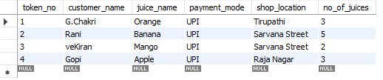

QUESTION 2
Manually populate the token number
Now we will explicitly give a token number.
Run:
INSERT INTO juiceshop_auto
(token_no, customer_name, juice_name, payment_mode, shop_location, no_of_juices)
VALUES
(10, 'Vasavi', 'Mango', 'UPI', 'Tirupathi', 3);

Now check:
SELECT * FROM juiceshop_auto;
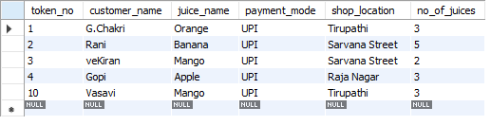
QUESTION 3
Drop the AUTO_INCREMENT
Now we remove the automatic numbering property from token_no.
Run:
ALTER TABLE juiceshop_auto
MODIFY token_no INT NOT NULL;
Now check:
DESC juiceshop_auto;
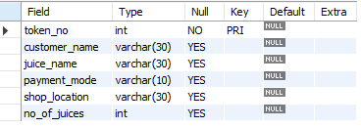

Verify manual entry after removing AUTO_INCREMENT
Now try inserting another record with a token number:

INSERT INTO juiceshop_auto
(token_no, customer_name, juice_name, payment_mode, shop_location, no_of_juices)
VALUES
(11, 'Ravi', 'Watermelon', 'Cash', 'Rani Street', 4);

Then:
SELECT * FROM juiceshop_auto;
The token number 11 is now entered manually.

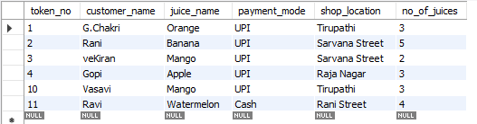

RESULT
The AUTO_INCREMENT sequence was successfully created and used to generate token numbers automatically. Token numbers were also inserted manually, and the AUTO_INCREMENT property was successfully removed from the table. This follows the three operations specified in Experiment 11 of your lab manual.

